How to Install MS Office Word 2003's Default Global Template in MS Office Word 2019 (and Earlier/Later Versions)

He Kaida
- Launch MS Office Word and go to the Developer tab. (The Developer tab isn't displayed by default, but you can add it to the ribbon. On the File tab, go to Options > Customize Ribbon. Under Customize the Ribbon and under Main Tabs, select the Developer check box, and click OK. After you show the tab, the Developer tab will stay visible.)

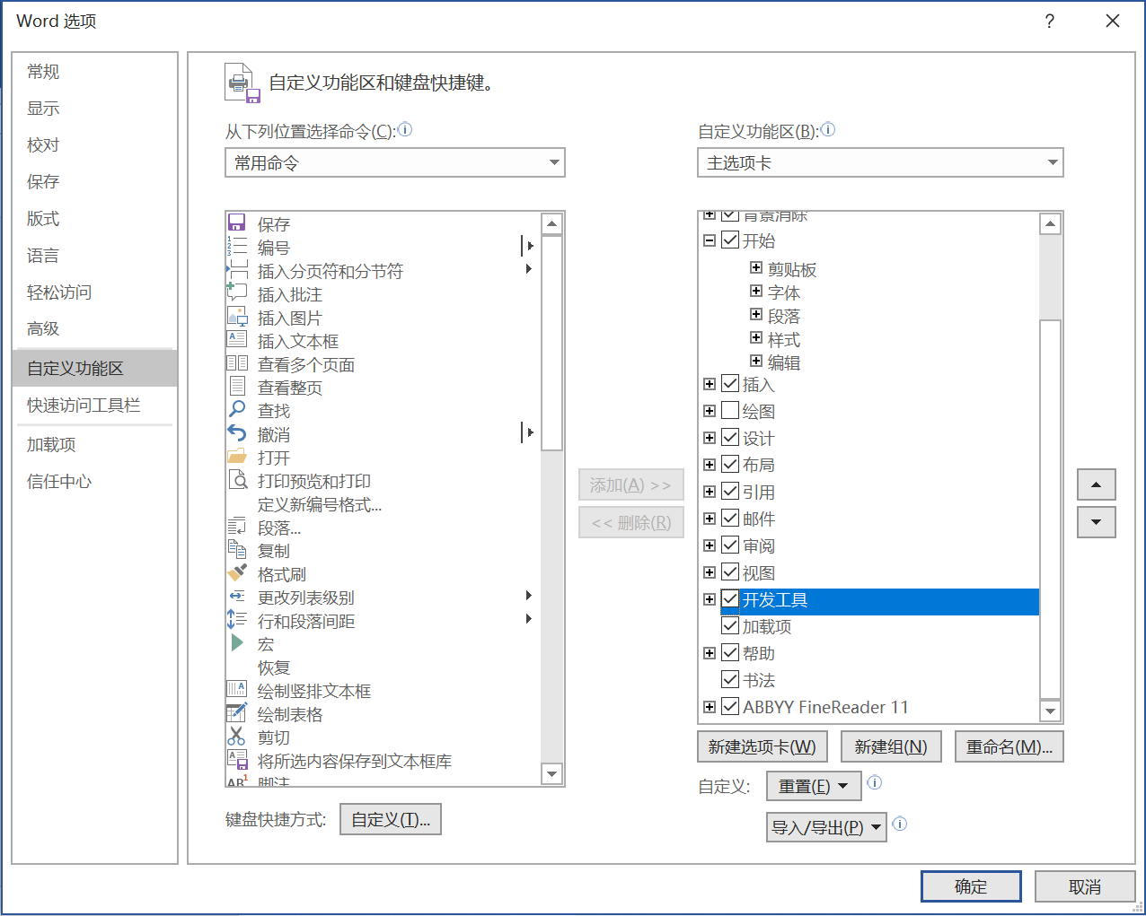

- Click the Word Add-ins button.
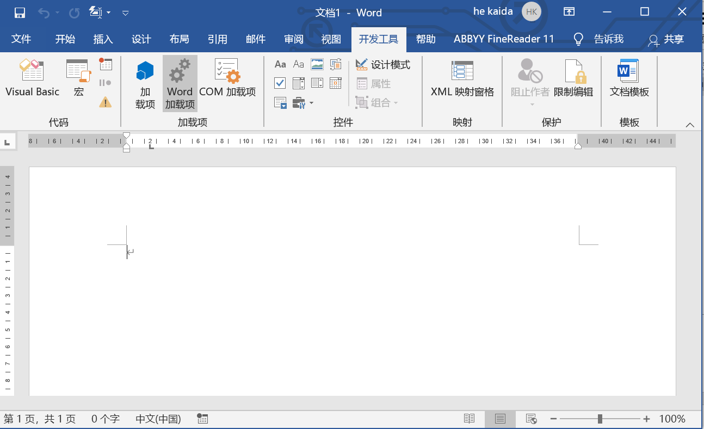

The Templates and Add-ins dialog box opens.

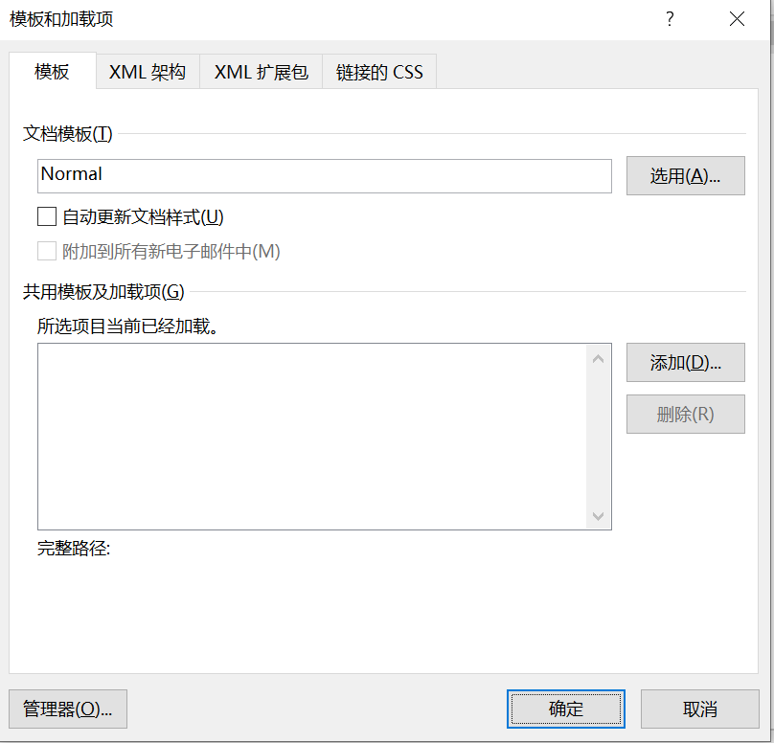

- Click Add, switch to the folder where templates are stored in MS Office. Copy the path.

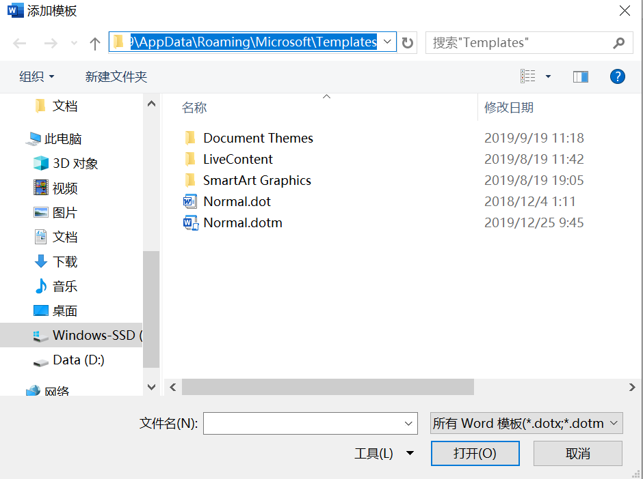

- Download “Normal.zip” to a folder in your computer. Unzip the “Normal.dot” in the file to the folder you have found in step 3 (paste the path). {If you are prompted for a password when unzipping the downloaded file, please send me an email at keping@nju.edu.cn, identifying yourself and telling me your purpose of using the template. I’ll email you the password as soon as I receive your email.}

- Return to the Templates and Add-ins dialog box in MS Office (click Developer tab> Word Add-ins). Click Add, switch to the folder where the Normal.dot is stored, find and select the Normal.dot (not Normal.dotm) and click OK.

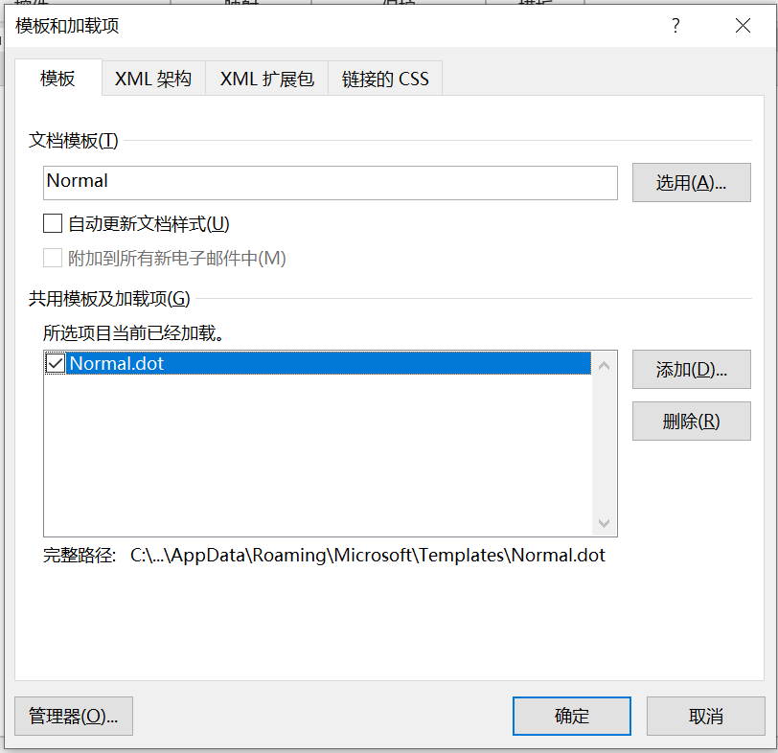
- Click the Organizer button in the Templates and Add-ins dialog box. The following box shows.
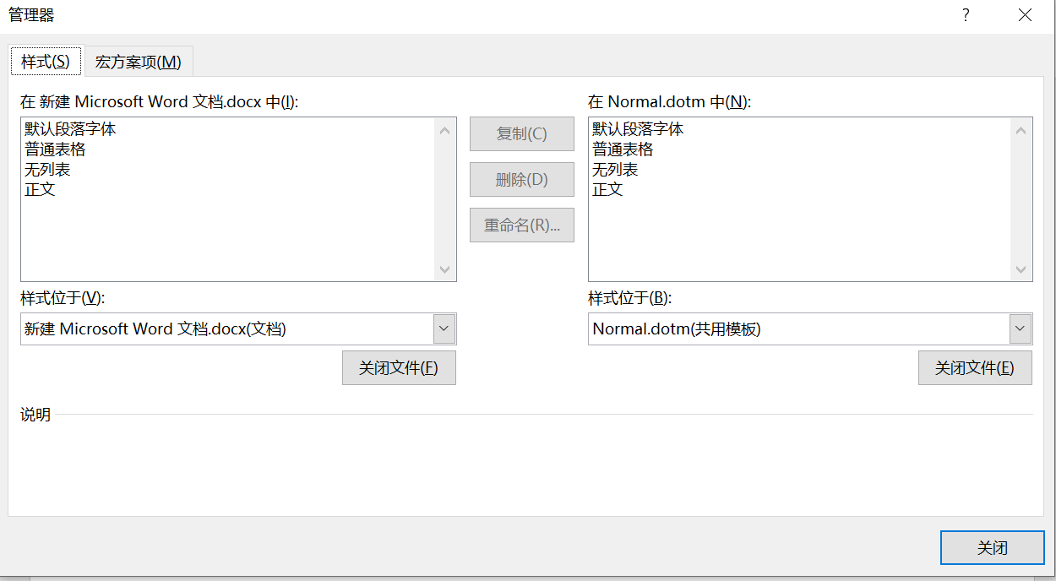

- Click the Close File button on the left side of the dialog box. The button changes its name and becomes the Open File button. Click the Open File button and, in the Open dialog box, find and select the Normal.dot; then, click the Open button. The names of styles in the Normal.dot appear in the list box on the left side.

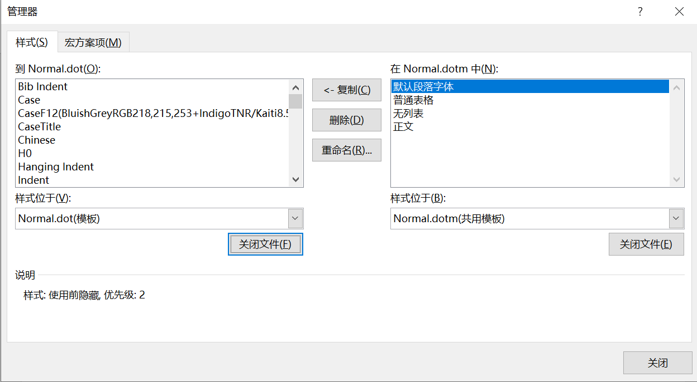
- Select all styles in the Normal.dot and click the Copy button to copy them to the Normal.dotm. (Please pay attention to the direction of this operation: don’t copy styles the other way around). The styles in the Normal.dot will then appear in the Normal.dotm list box on the right side. Click Save when Word asks whether you want to save the new styles in the template.
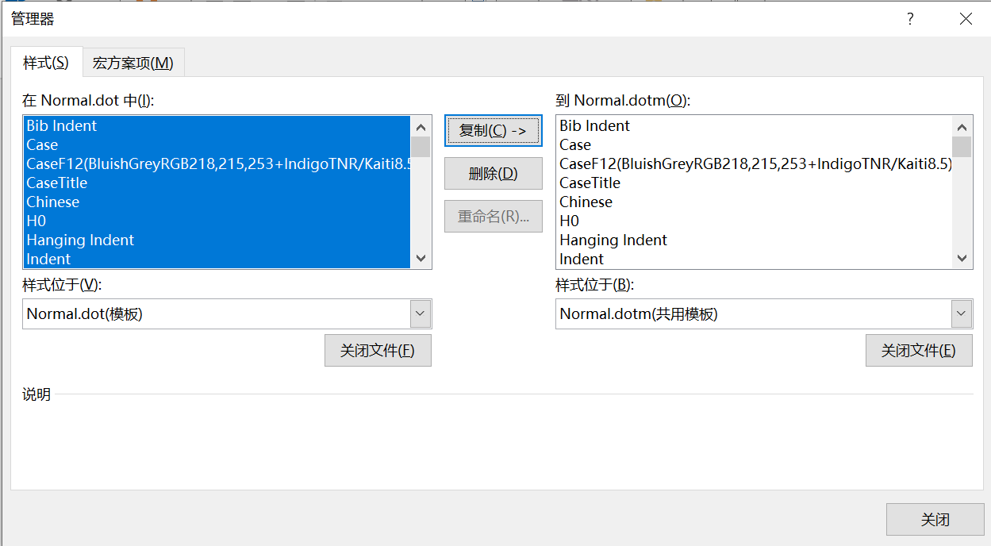
- Click Close. Now MS Office Word 2003's Default Global Template can be used in the opened document. When exiting the document, click Save when Word asks whether you want to save the new Normal.dotm.

* Later, when you want to use MS Office Word 2003's Default Global Template in any new document you create or open in MS Office Word 2019:
1. Open the Templates and Add-ins dialog box in MS Office Word 2019 (click Developer tab> Word Add-ins)
2. Click the Normal.dot. (If the Normal.dot is already selected, then skip this step.)

3. Click OK. Then the MS Office Word 2003's Default Global Template can be used in the new document.

(December, 2019)

